Sabotage on the death railway

1st April 1943: Allied POWs forced to work on the bridge on the River Kwai do everything to undermine its structure
APR 1

SAVE |  | ▷ LISTEN

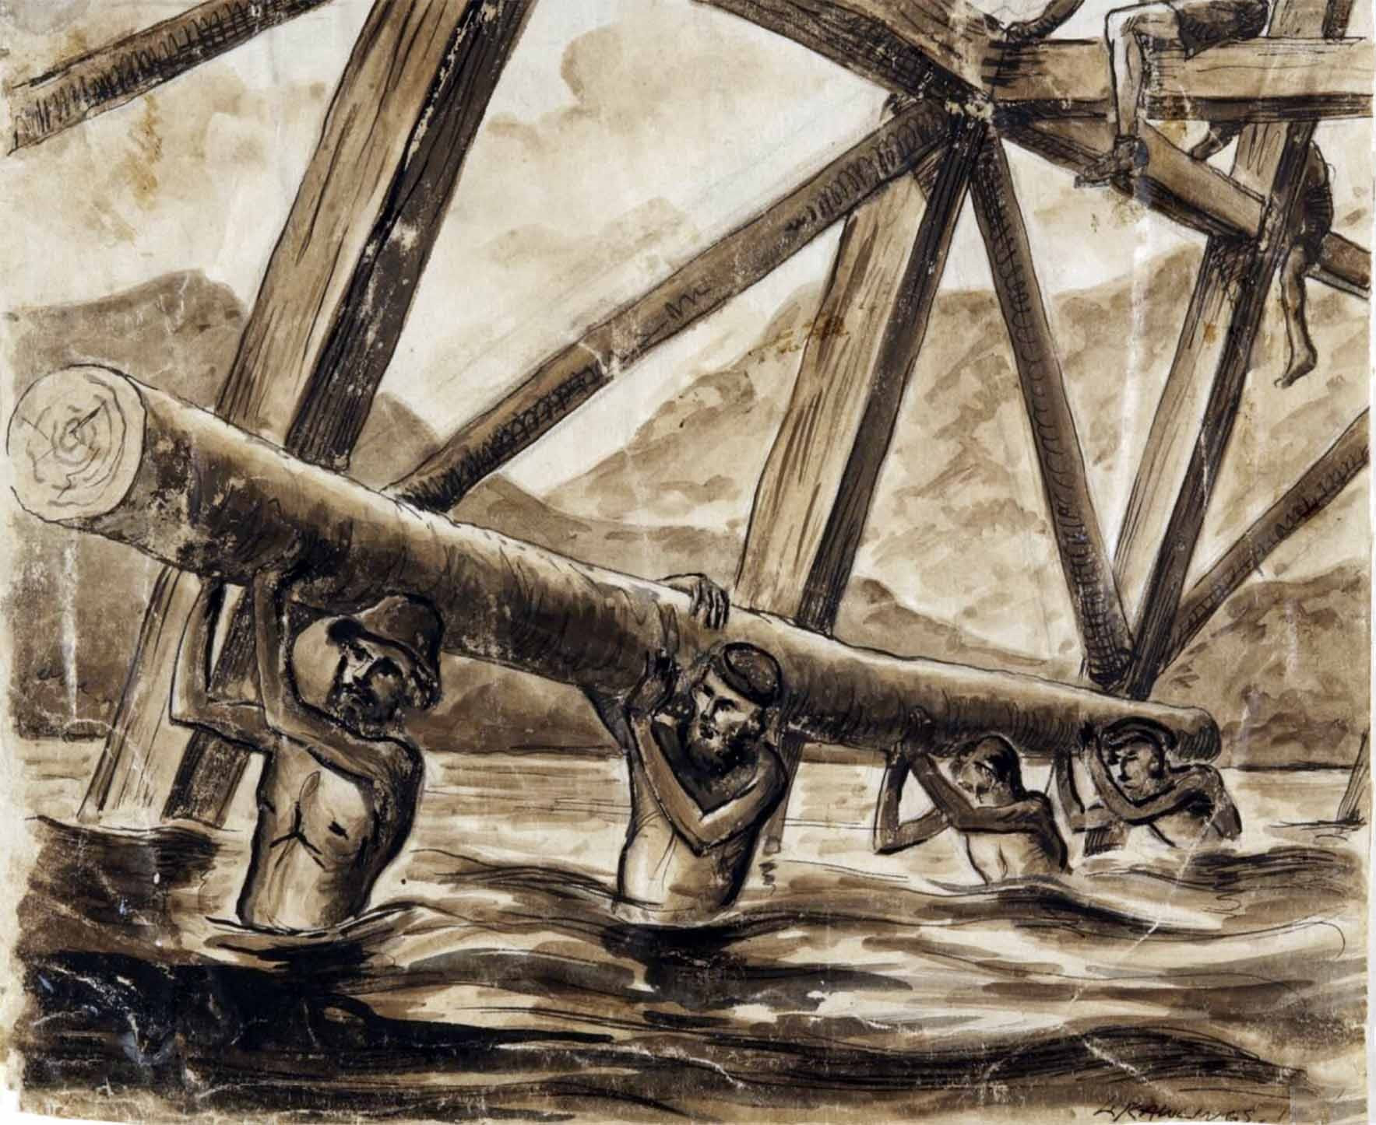
‘Bridge over the River Kwai’ L. Rawlings, 1943, another prisoner who produced remarkable artwork and managed to conceal it to the end of the war.
On the Railway of Death - which the Japanese were forcing POWs to build through the jungles of Burma and Siam - there was no respite.
Australian Don McLaren¹ had survived the nightmare journey by box car up to the jungle camps from Singapore.
On the 1st April 1943 he found himself at the beginning of a new ordeal, the construction of a bridge:
It was still dark when the guard was yelling. 'All men out, all men out.’ Here we faced an enormous natural gully.
A timber framed bridge would eventually span this gully, we called it 'The Pack of Cards.’ We hauled these teak logs in from the jungle. First we had to drive the logs, sharpened at one end, into the ground.
Next we shaved off one side with crude axes to make it possible to keep going up and up. The Jap engineers rigged up this piledriving apparatus. We had long ropes. Hundreds of Australians would walk back until the rope was taut, then we’d sing, ’Ichy, nee. Nisio, nisio, nisio.’ (One, two. Pull, pull, pull.)
As we sang these numbers, we’d pull on the rope. This huge great lump of steel would rise up. On the last ’nisio’ we would all let go. Down would come the pile-driver and the pole would sink another inch. All day seven days a week, for weeks on end, with not a single day off, we drove these bloody things into the ground.
It was the crudest bridge one could ever wish to see. I hope I never have to go over it in a train.
Quite a few Japs had sore heads. Every time a chance came along, some items would fall from the bridge and hit a Nip on the cranium. The stupidity of the Jap guards was their continuous screaming of 'More sing, more singl' We would all be yelling ’lchy nee, nisio!’, but it took more out of our emasculated bodies to sing and tug at the same time.
The bridge is equal to a four storey building. While we were still hauling timbers up to complete it, every Australian saw this bloody Jap fall off the top. Next thing, an arm comes out and grabs the falling object. So here’s this Aussie holding this Jap by the neck of his shirt. We were all yelling, 'Drop the bastard, drop the bastardl’ The Aussie yelled back, 'I can’t, the bastards are on to mel’
We did an enormous amount of sabotage to this structure. Over half the timbers that were cased out with another piece shaped to fit into the cased area were broken. Often the cased out section would be filled with sand and small stones. It was the crudest bridge one could ever wish to see. I hope I never have to go over it in a train.
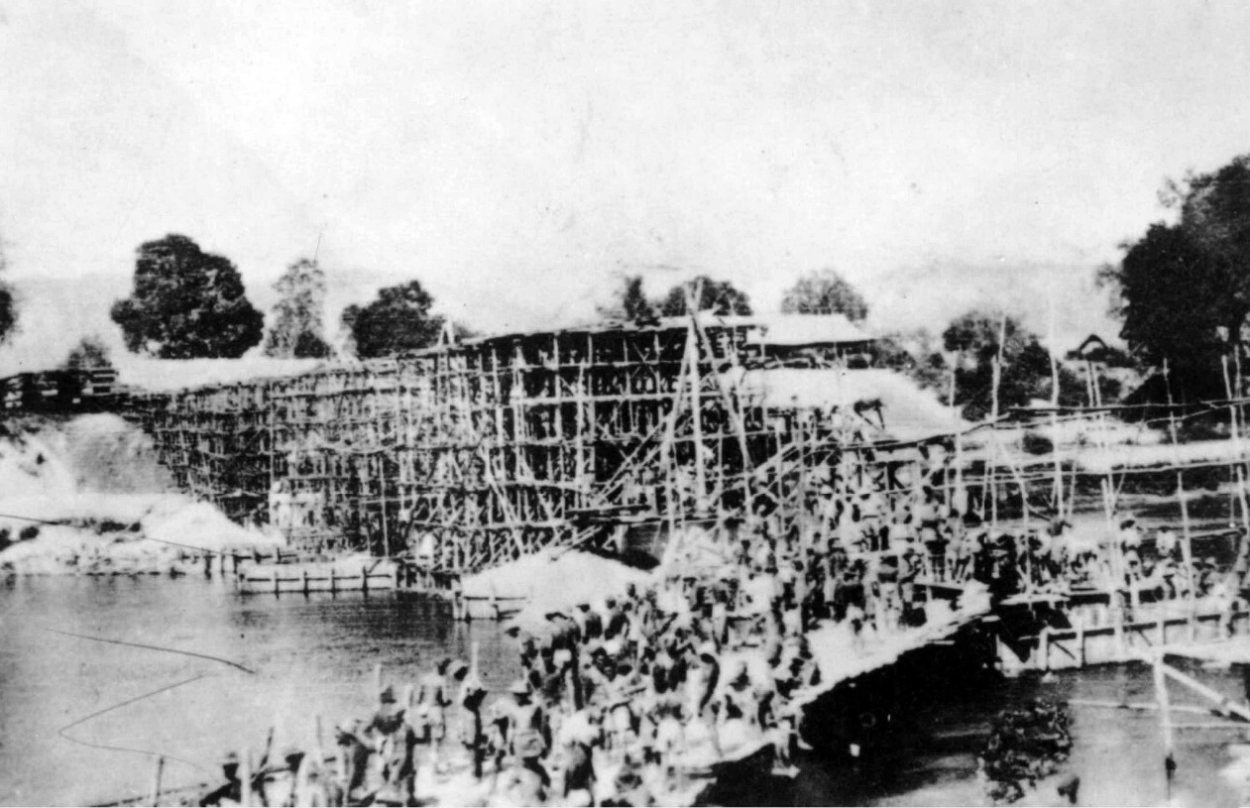
Allied prisoners of war constructing the Tamakan bridge over the Kwai Noi River. At this stage the bridge site is covered in scaffolding made from bamboo.
1
Don McLaren: Mates in hell: the secret diary of Don McLaren, POW of the Japanese 1942-1945. Hard to obtain but available from the National Library of Australia.

